On Thursday 27th June we were very fortunate to have the NHS come into school to talk to our Year 5 and Year 8 students about careers within the NHS and Dorchester County Hospital in particular. We welcomed Tom and Vicky from the education department’s widening participation team who delivered a presentation on the huge number of different career paths available within the NHS along with a hands-on look at some of the more ‘interesting’ aspects of some jobs in hospitals.
It was great to see how knowledgeable our students were and also how well they engaged with the sessions. I hope that it has given them food-for-thought when considering what they may wish to do in their future lives.
I have attached some posters highlighting labour market information relating to careers in Dorset and in particular those within the Health & Care sectors.
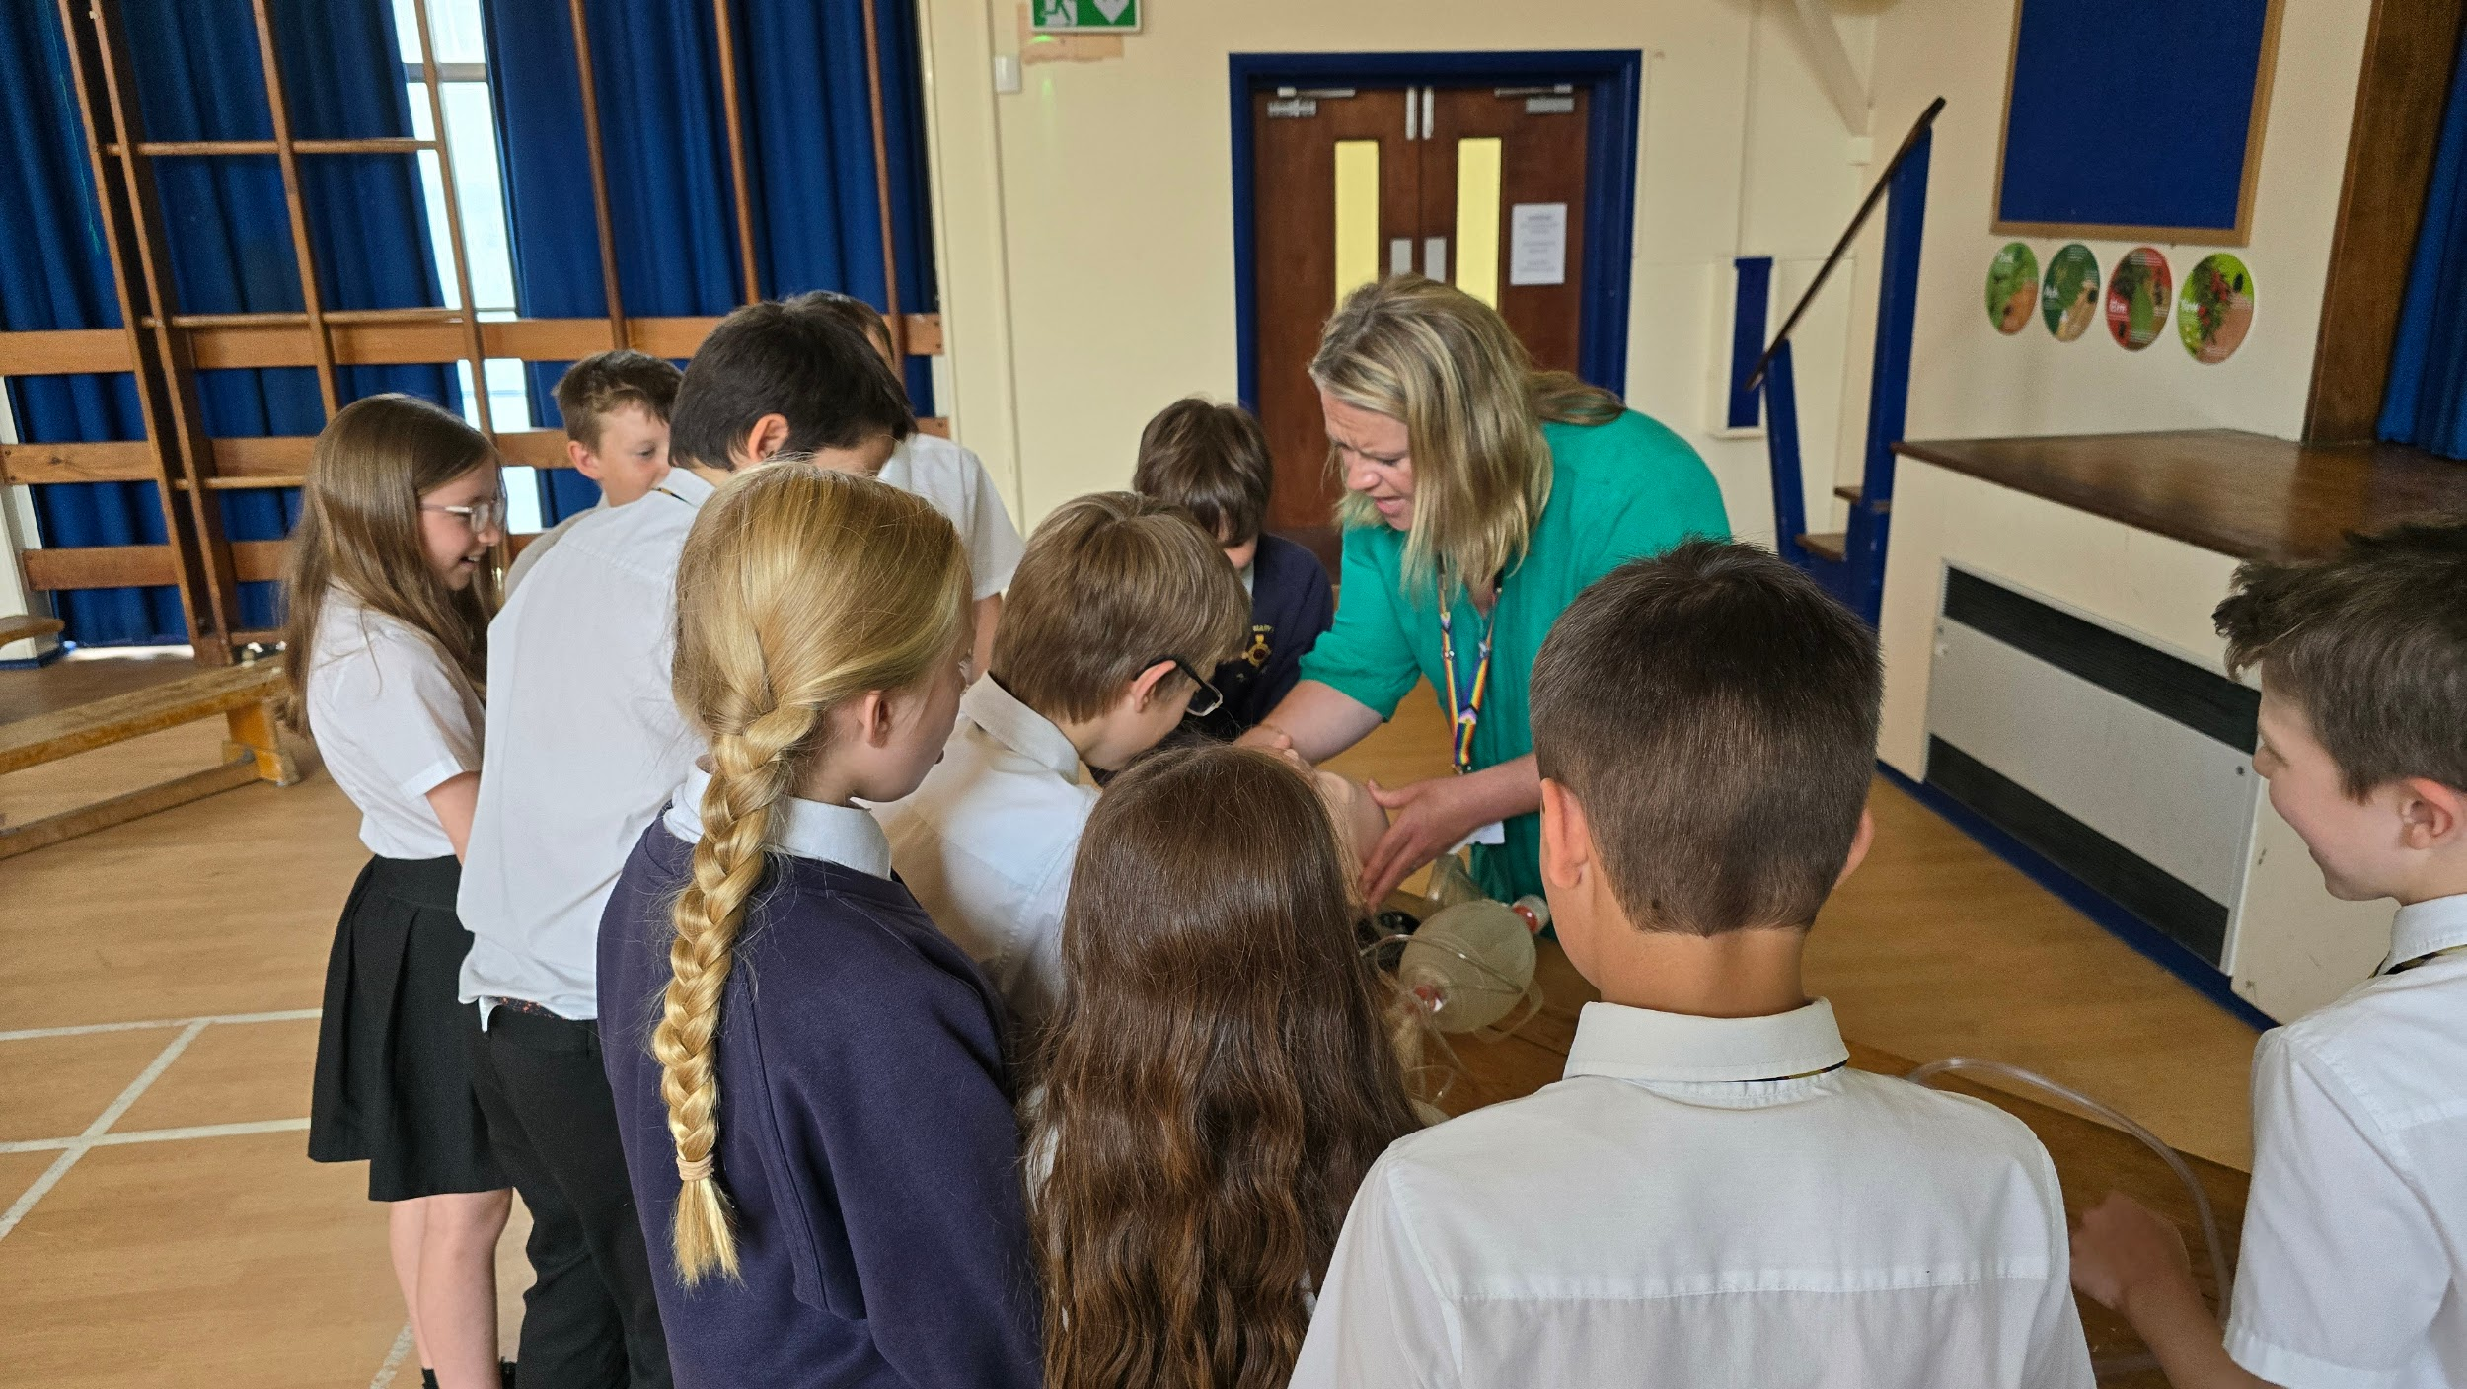
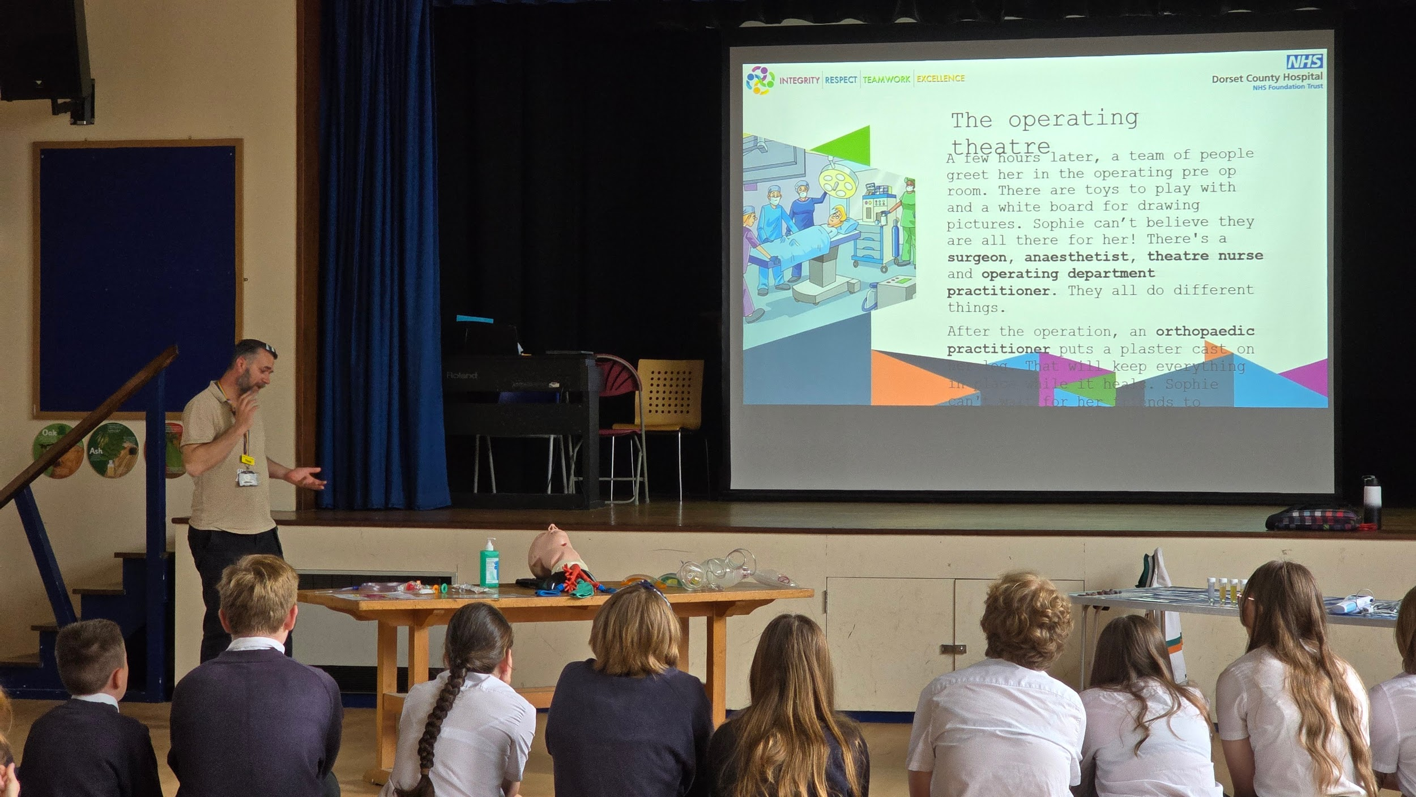
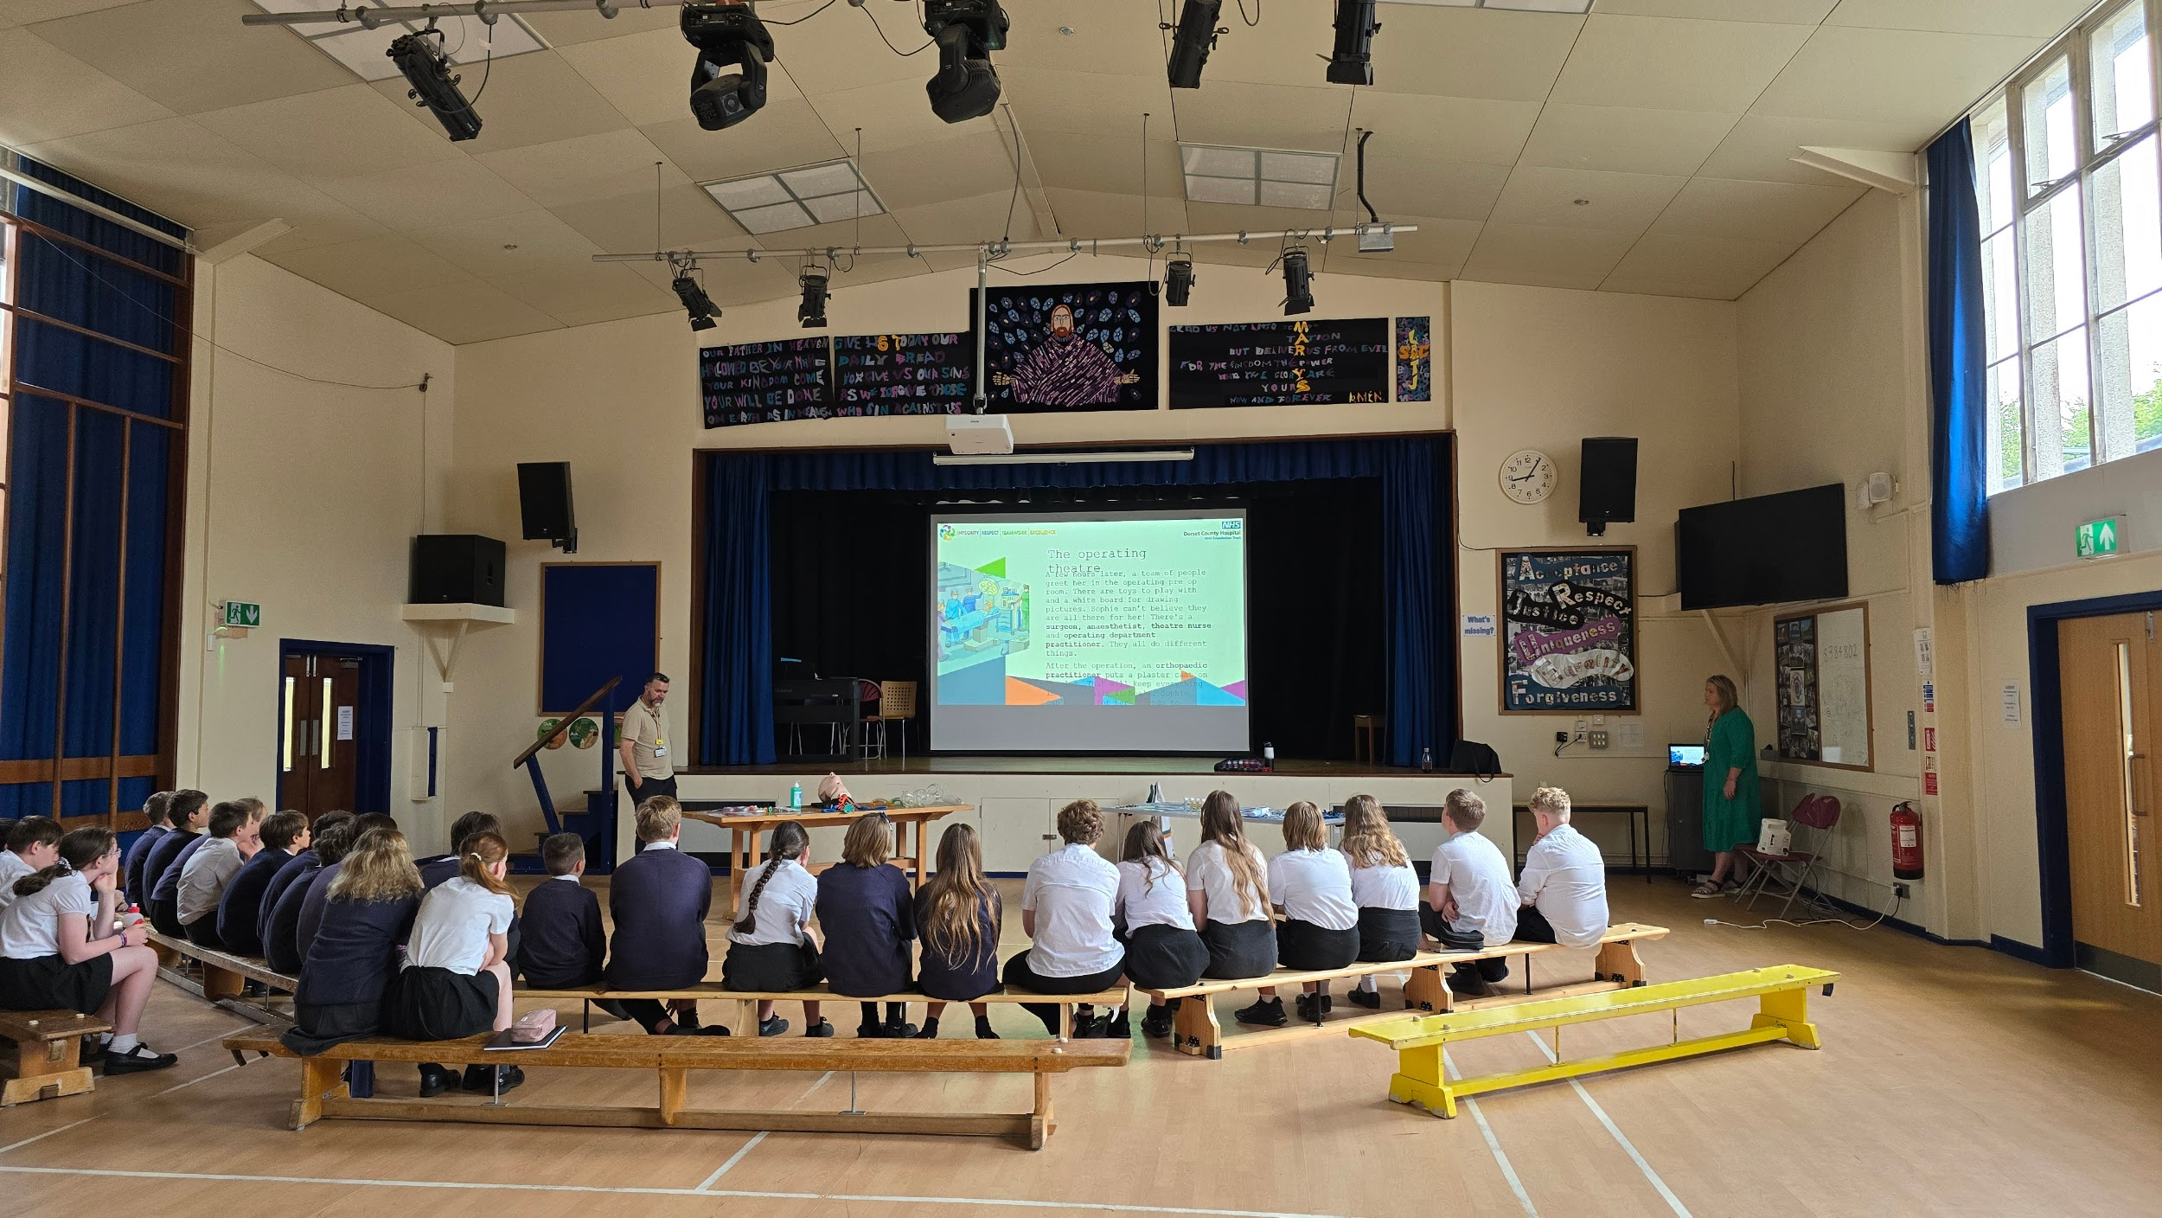
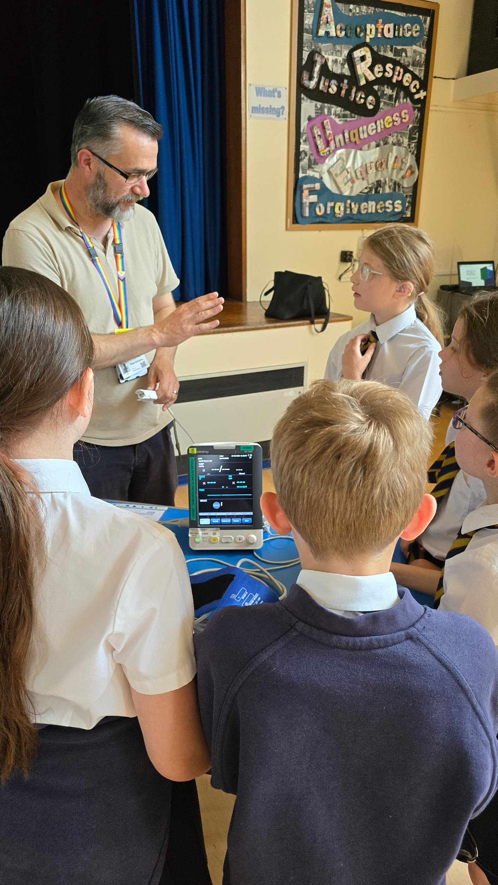
Did you know? There are over 350 different career options within the NHS, from frontline healthcare professionals to ground staff, accountants and IT technicians.
I have also included some photographs from the event.
Mr. Tubb.


